L04: Activity Reflection (Learning Journal)
After completing the activity, fill in the table below.
Instructions
- Choose two features from your activity
(for example: DOM selection, button event, updating text, input value, counter function).
- Copy 3–6 lines of code related to that feature.
- Write 1–2 sentences explaining what the code does.
Feature Used | AI tool - prompt Used  Write the prompt you used | Code Generated by AI  Copy a small section of the code related to the feature | What I Modified  Describe what you changed | What This Code Does  Explain what the code does
Example:  Button Click Event | ChatGPT - Generate JavaScript code that changes text color when a button is clicked | 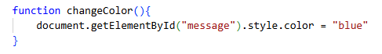 | Changed the text message and connected the function to a button click. | This code changes the text color of the heading when the user clicks the button.
Button Click Event | Create a JavaScript function that gets a value from an input field, checks if it's empty, and shows an alert message | 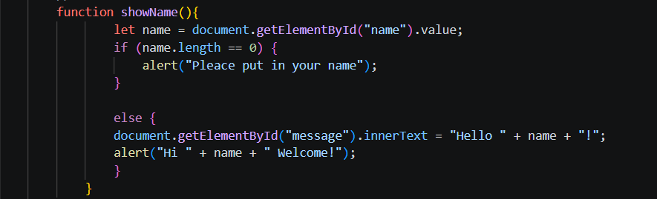 | Added the else block to display a personalized message on the screen using innerText, and added a second alert() to confirm the submission | This code retrieves the text a user types into the input field, checks if the field is empty, and shows a warning alert if no name is entered. If a name exists, it displays a personalized welcome message both on the screen and in a pop-up alert.
 | Create a simple counter with plus and minus buttons; clicking it updates the numbers on the page. | 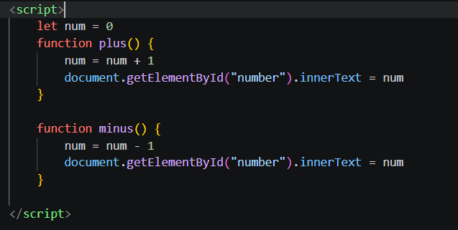 | Split the code that was originally written together into two separate functions, plus() and minus(), and ensured that the numbers were updated in real time. | When the user clicks "+", the number increases by 1; when they click "-", the number decreases by 1.

